PROGRESS REPORT

- GENERAL INFORMATION

Organization | Josip Matos Primary school
Reporting period | March 2019 – November 2019

- DESCRIPTION OF THE ACTIVITIES CARRIED OUT IN THIS PERIOD

PROJECT ACTIVITY | DESCRIPTION
8.3.2019. swimmning | Swimming at swimming pool Vukovar (our associated partner)
15.3.2019. swimming | Swimming at swimming pool Vukovar (our associated partner)
22.3.2019. School project team meeting | Information about project activities and discussing the material for the guideline about beneficial effects of sports
5.4.2019. Hypotherapy | Hypotherapy in local Equestrian club »Dunavski raj«
12.4.2019. Swimming | Swimming at swimming pool Vukovar (our associated partner)
30.4.2019. swimming | Swimming at swimming pool Vukovar (our associated partner)
3.5.2019. sports activities | Sports activities at Sports facilities Vukovar (our associated partner)
10.5.2019. Swimming | Swimming at swimming pool Vukovar (our associated partner)
15.5.2019. sports activities (football) | Interschool football competition in Josip Matos Primary School
31.5. 2019. Swimming | Swimming at swimming pool Vukovar (our associated partner)
4.6. 2019. Hypotherapy | Hypotherapy in local Equestrian club »Dunavski raj«
7.6.2019. swimming | Swimming at swimming pool Vukovar (our associated partner)
14.6.2019. sports activities at the end of school year (the basics of karate and boxing) | The basics of karate and boxing in Josip Matos Primary School
3.7.2019. School project team meeting | Information about project activities and discussing the material for the guideline about beneficial effects of sports
28.8.2019. School project team meeting | Discussion about project activities and information for teachers abou project (discussing material for the guideline about beneficial effects of sports)
13.9.2019. Tennis | The basics of tennis at Sports Facilities Vukovar (our associated partner)
20.9.2019. swimming | Swimming at swimming pool Vukovar (our associated partner)
27.9.2019. swimming | Swimming at swimming pool Vukovar (our associated partner)
4.10.2019. sports activities | Sports activities at Sports facilities Vukovar (our associated partner)
10.10.2019. Tennis | The basics of tennis at Sports Facilities Vukovar (our associated partner)
17.10.2019. | The basics of tennis in Josip Matos Primary School
25.10.2019. School project team meeting | Preparing and discussing the materials for the list of sports activities
30.10.2019. School project team meeting | Preparing and discussing the materials for the list of sports activities
6.11.2019. School project team meeting | Preparing and discussing the materials for the list of sports activities
13.11.2019. swimming | Swimming at swimming pool Vukovar (our associated partner)
21.11.2019. Tennis | The basics of tennis in Josip Matos Primary School
27.11.2019. swimming | Swimming at swimming pool Vukovar (our associated partner)

- DISSEMINATION

DATE | TYPE OF ACTIVITY (e-mail, newsletter, article, radio,your website, your Facebook page) | SHORT DESCRIPTION | TARGET GROUP | EFFECTS/IMPACTS
12.7.2019. | Presentation of project and project activities at Teacher Councile | Information about project, goals, activities, meetings | Teachers in Josip Matos Primary School | School level
4. 11. 2019. | School website | Information about project, goals, activities, meetings | Parents, local community | Local community
29.11.2019. | Day of Education and Teaching Training Agency | Swimming at swimming pool Vukovar (our associated partner) | Professionals in education | State level

- PICTURES OF THE ACTIVITIES

Post pictures from your activies and write very short description of the pictures (one sentence for each pictures).
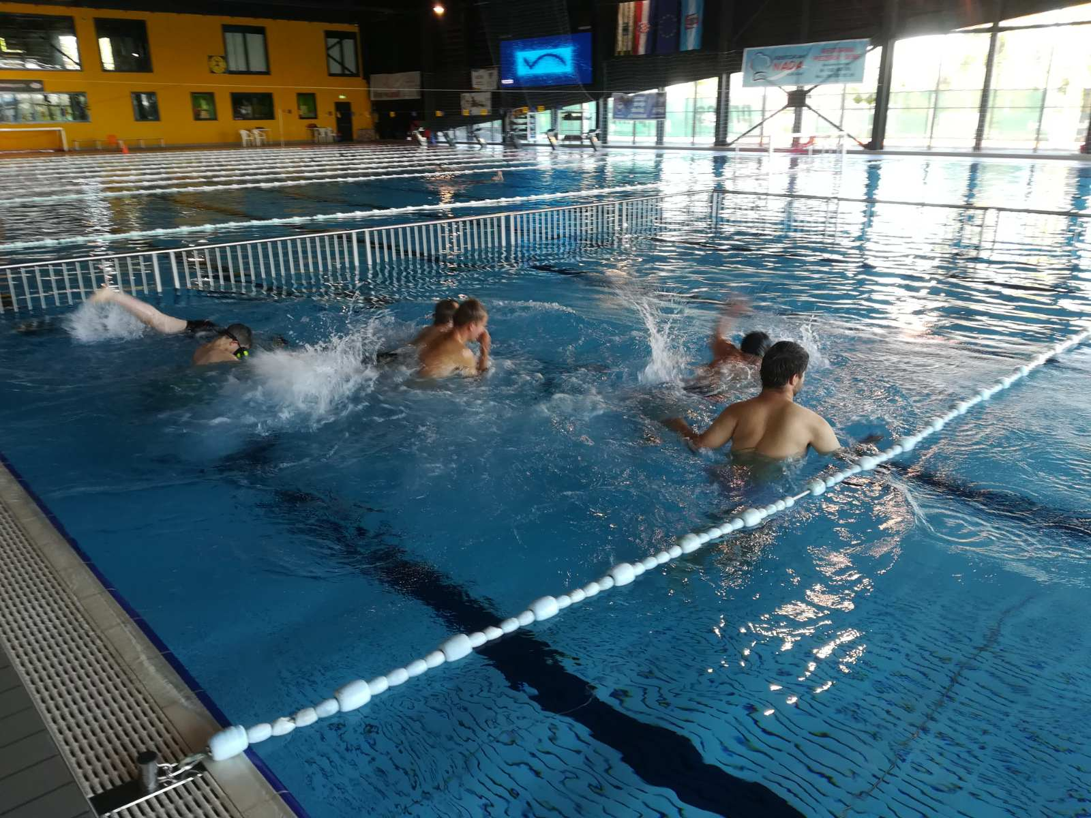
Preparing activities for swimming
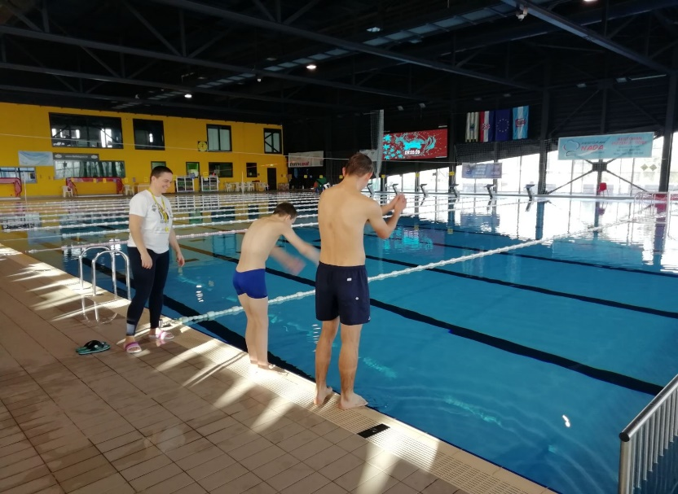
Learning jumping technique

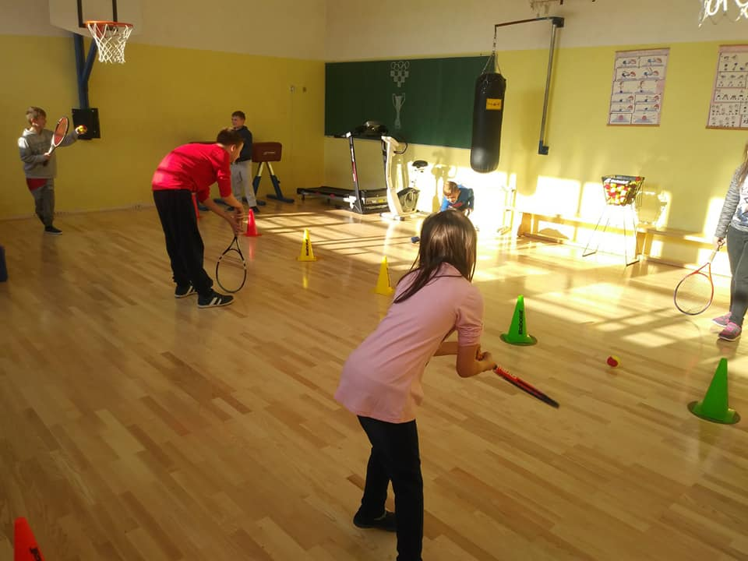

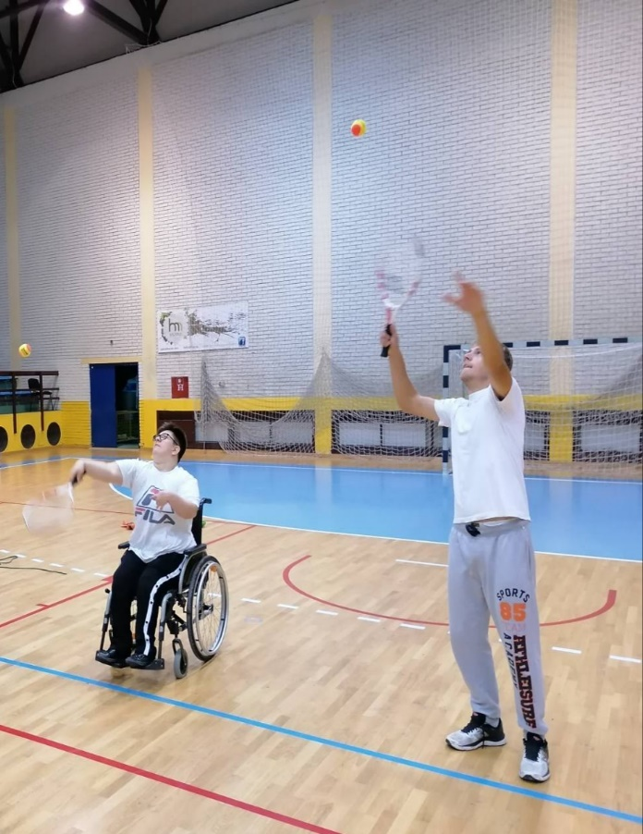
Learning the basics of tennis

Hypotherapy-riding
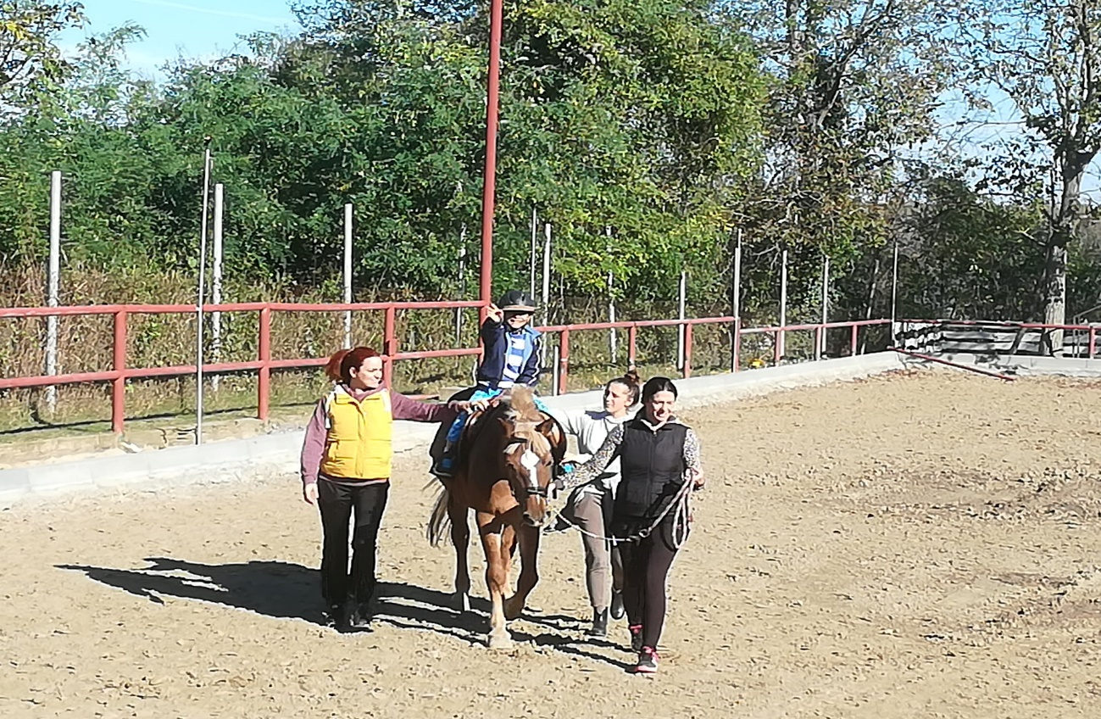

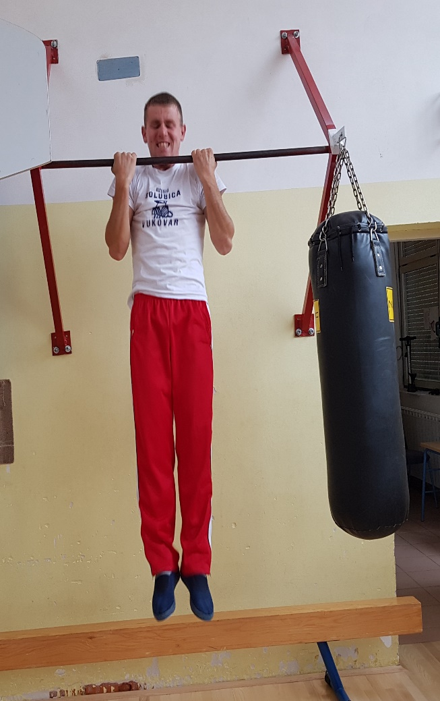
Strenght exercises

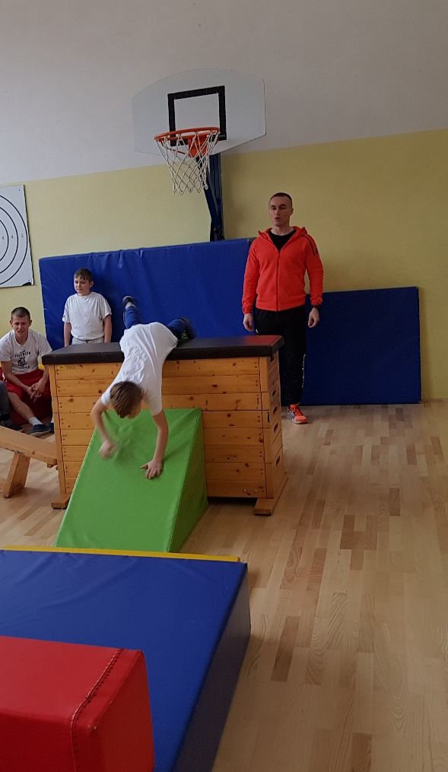
Improving general motor skills

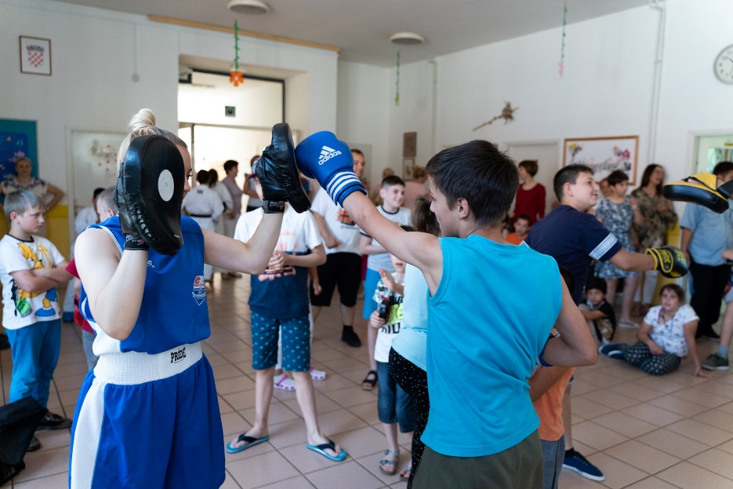

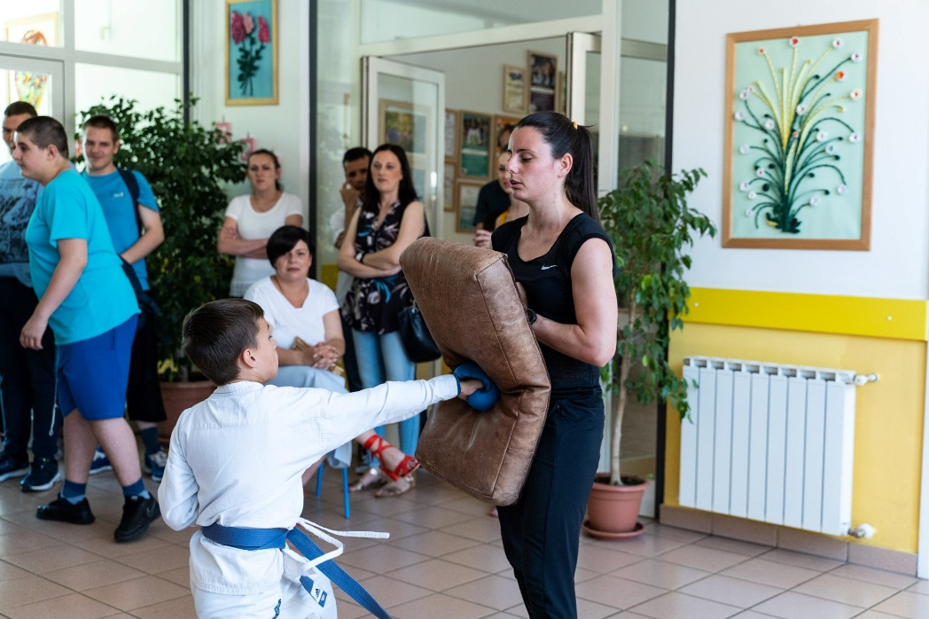
The basics exercises of boxing and karate

