**PROGRESS REPORT**

1. **GENERAL INFORMATION**

|  |  |
| --- | --- |
| Organization | Sport Sciences Faculty - University of Coimbra |
| Reporting period | March 2019 – December 2019 |

1. **DESCRIPTION OF THE ACTIVITIES CARRIED OUT IN THIS PERIOD**

|  |  |
| --- | --- |
| PROJECT ACTIVITY | DESCRIPTION |
| 14 and 15/05/2019 | Review of the NEEDSPORT´s Project Design Proposal |
| 16/06/2019 | Oral presentation at ISAPA 2019 Conference (USA, 14-18 of June 2019) |
| 04/09/2019 | Review and development of the final version of the Meeting Assessment Questionnaire |
| 11/09/2019 | Development of the first draft of the Activities/Workshops Assessment Questionnaire |
| 16/09/2019 | Development of the first draft of the Activities/Workshops Assessment Questionnaire |
| 24/09/2019 | Development of the first draft of the Teachers/Instructor Questionnaire for the Assessment of children progress |
| 27/09/2019 | Development of the first draft of the Parents Assessment Questionnaire and of the Participants Assessment Questionnaire |
| 04/10/2019 | Final proposal of the Activities/Workshops Assessment Questionnaire and of the Activities/Workshops Assessment Questionnaire |
| 12/10/2019 | Final proposal of the Teachers/Instructor Questionnaire for the Assessment of children progress |
| 19/10/2019 | Final proposal of the Parents Assessment Questionnaire and of the Participants Assessment Questionnaire |
| 23/10/2019 | Production of the eletronic version of the Meeting Assessment Questionnaire for dissemination (Rogaska) |
| 27/11/2019 | Production of the eletronic version of the Meeting Assessment Questionnaire for online dissemination (Patras) |

1. **DISSEMINATION**

|  |  |  |  |  |
| --- | --- | --- | --- | --- |
| DATE | TYPE OF ACTIVITY (e-mail, newsletter, article, radio,your website, your Facebook page) | SHORT DESCRIPTION | TARGET GROUP | EFFECTS/IMPACTS |
| 30/12/2019 | Available at Faculties webpage fcdef.uc.pt | NeedSport Project EU funding news | University students & general public | 1385 views  upgrade |
| 30/12/2019 | Facebook | NeedSports project EU news [published in 11.03.2019] | Social network | 454 views  upgrade |
|  |  |  |  |  |
|  |  |  |  |  |
|  |  |  |  |  |
|  |  |  |  |  |
|  |  |  |  |  |
|  |  |  |  |  |
|  |  |  |  |  |

1. **PICTURES OF THE ACTIVITIES**

Fotos from the oral presentation in the International Symposium of Adapted Physical Activity 2019, Charlottesville, USA by José Pedro Ferreira [14-18 June]

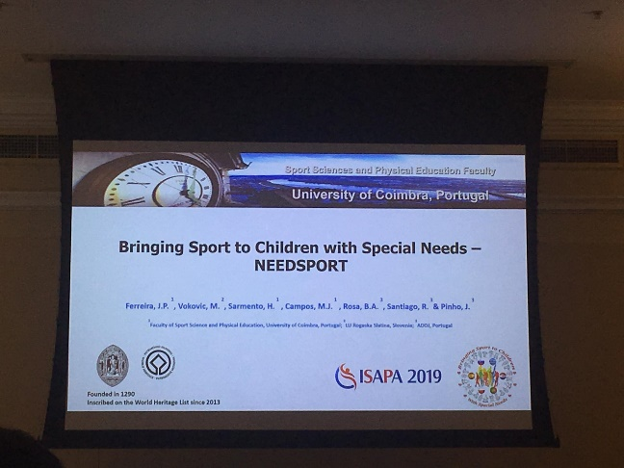

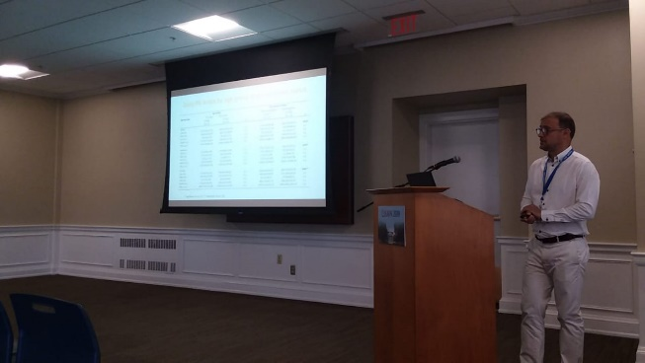

Abstract from the oral presentation in the International Symposium of Adapted Physical Activity 2019, Charlottesville, USA by José Pedro Ferreira [14-18 June]



Power point from oral presentation at the International Symposium of Adapted Physical Activity 2019, Charlottesville, USA by José Pedro Ferreira [14-18 June] (full document in attachment)

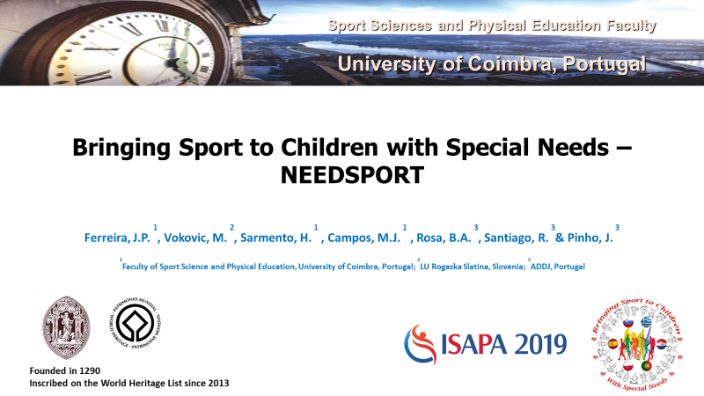

Dissemination of NeedSport using the Sport Sciences Faculty Center of Studies of Adapted Physical Activity web page available for students, professionals and overall community [454 views]

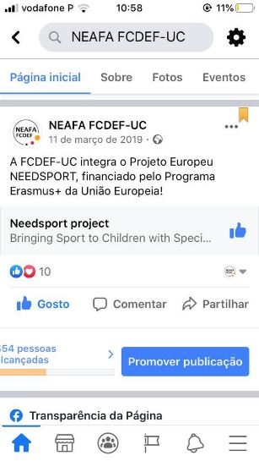

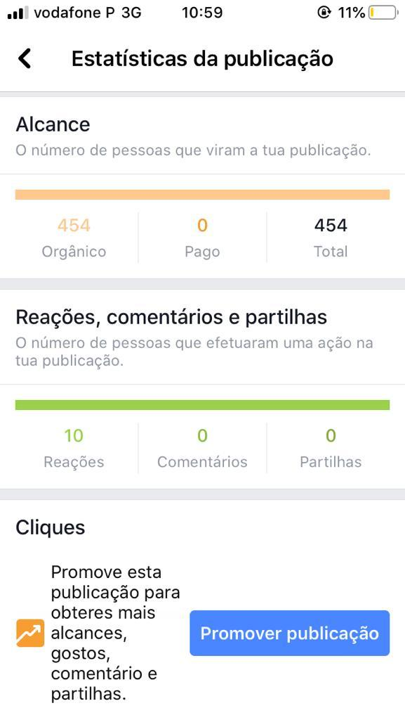

Dissemination of NeedSport using the Sport Sciences Faculty Center of Studies of Adapted Physical Activity web page available for students, professionals and overall community.



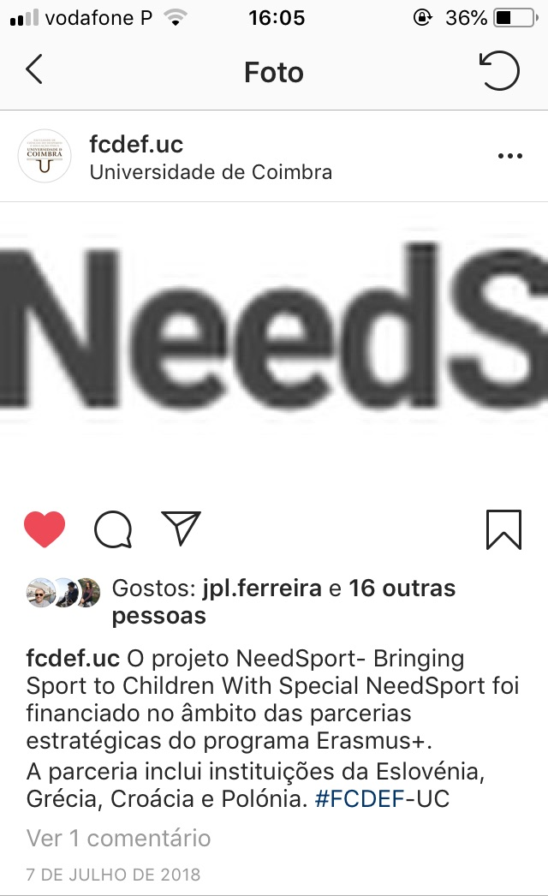

Instagram with NeedSports EU funding news [published in 7.07.2018]