PROGRESS REPORT

- GENERAL INFORMATION

Organization | Josip Matos Primary school
Reporting period | September 2018 – February 2019

- DESCRIPTION OF THE ACTIVITIES CARRIED OUT IN THIS PERIOD

PROJECT ACTIVITY | DESCRIPTION
6. 10. 2018. Hypotherapy | Hypotherapy in local Horse club »Dunavski raj«
18. 10. 2018. Hypotherapy | Hypotherapy in local Horse club »Dunavski raj«
19. 10. 2018. swimming | Swimming in swimming pool Vukovar (our associated partner)
31. 10. 2018. swimming | Swimming in swimming pool Vukovar (our associated partner)
7. 12. 2018. Swimming | Swimming in swimming pool Vukovar (our associated partner)
17. 12. 2018. School project team meeting | Discusion about project activities and information for teachers about project (discussing the material for the guideline about beneficial effects of sports)
28. 1. 2019. Teachers meeting | Information about project activities and discussing the material for the guideline about beneficial effects of sports
1.2. 2019. Swimming | Swimming in swimming pool Vukovar (our associated partner)
8.2. 2019. Swimming | Swimming in swimming pool Vukovar (our associated partner)
22. 2. 2019. Swimming | Swimming in swimming pool Vukovar (our associated partner)
27. 2. 2019. Hypotherapy | Hypotherapy in local Horse club »Dunavski raj«

- DISSEMINATION

DATE | TYPE OF ACTIVITY (e-mail, newsletter, article, radio,your website, your Facebook page) | SHORT DESCRIPTION | TARGET GROUP | EFFECTS/IMPACTS
25. 1. 2019. | School website | Information about project, goals, activities, meetings | Parents, local community | Local community

- PICTURES OF THE ACTIVITIES

Post pictures from your activies and write very short description of the pictures (one sentence for each pictures). 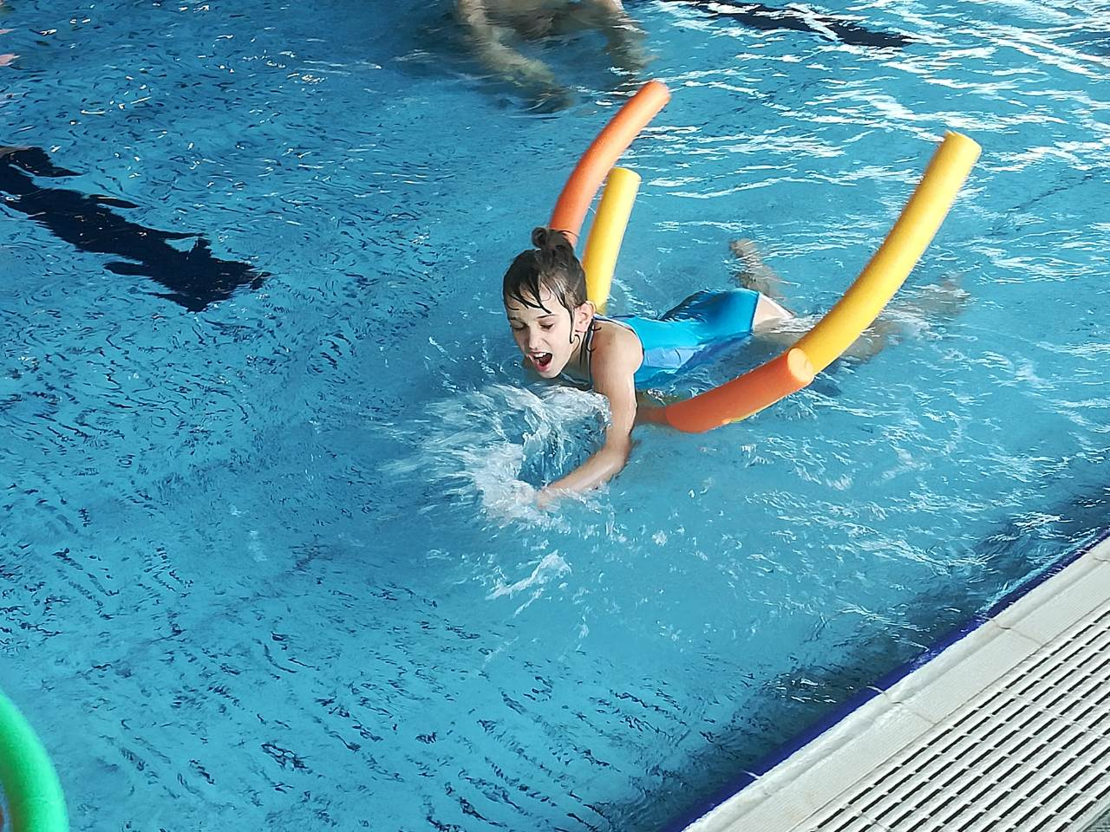
Swimming pool Vukovar- students learn how to swimm
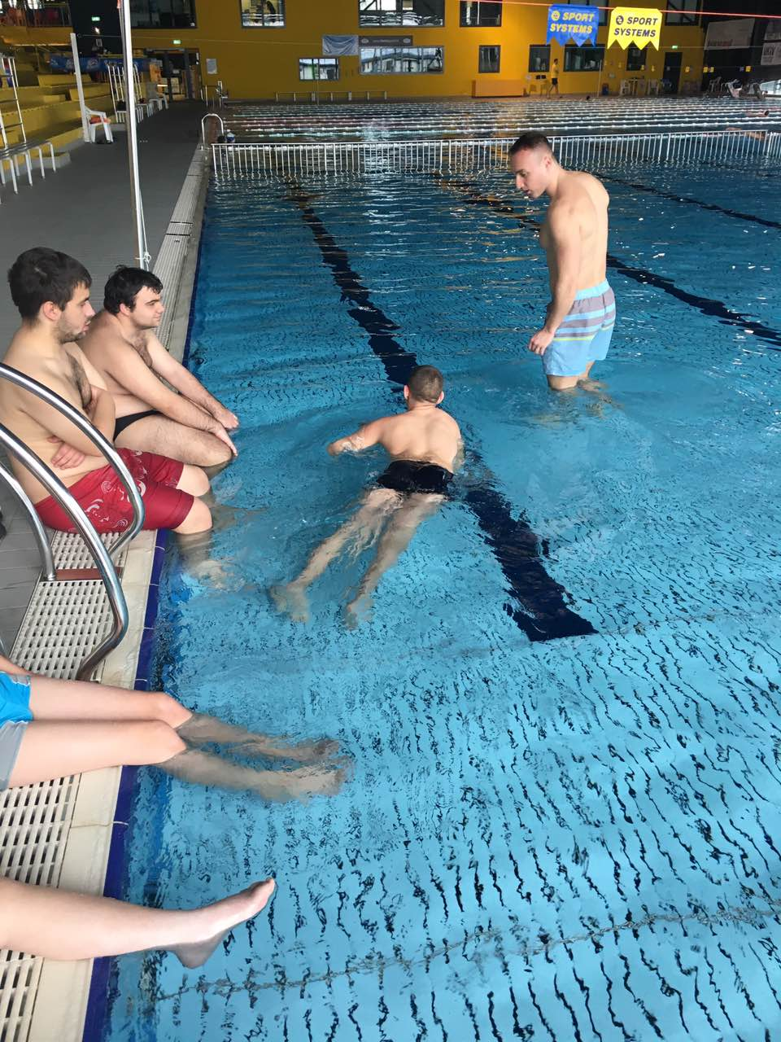
Preparing activities for swimming
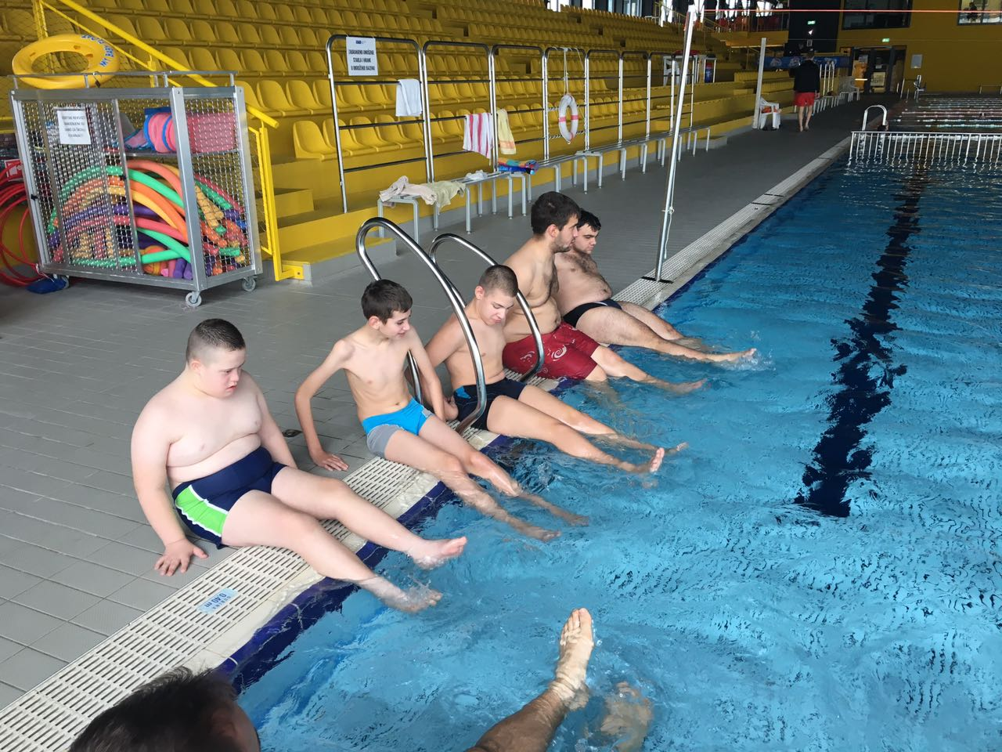
Preparing activities before swimming
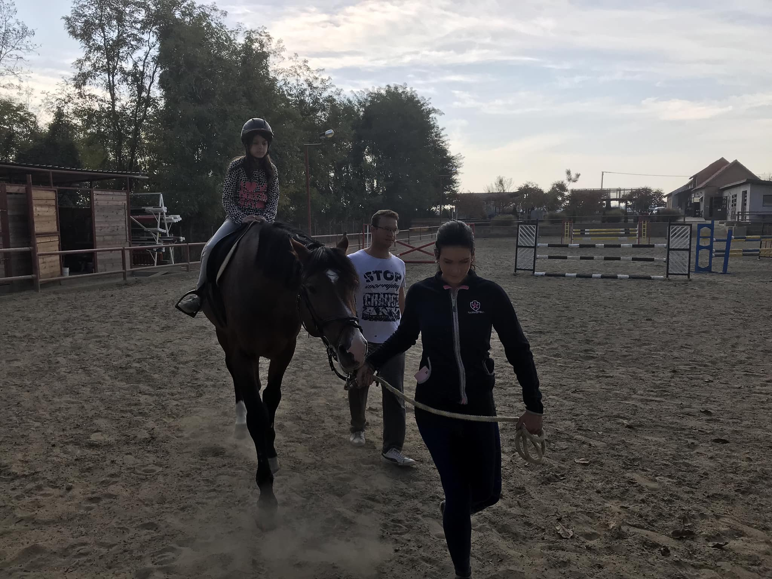
Hypotherapy-riding
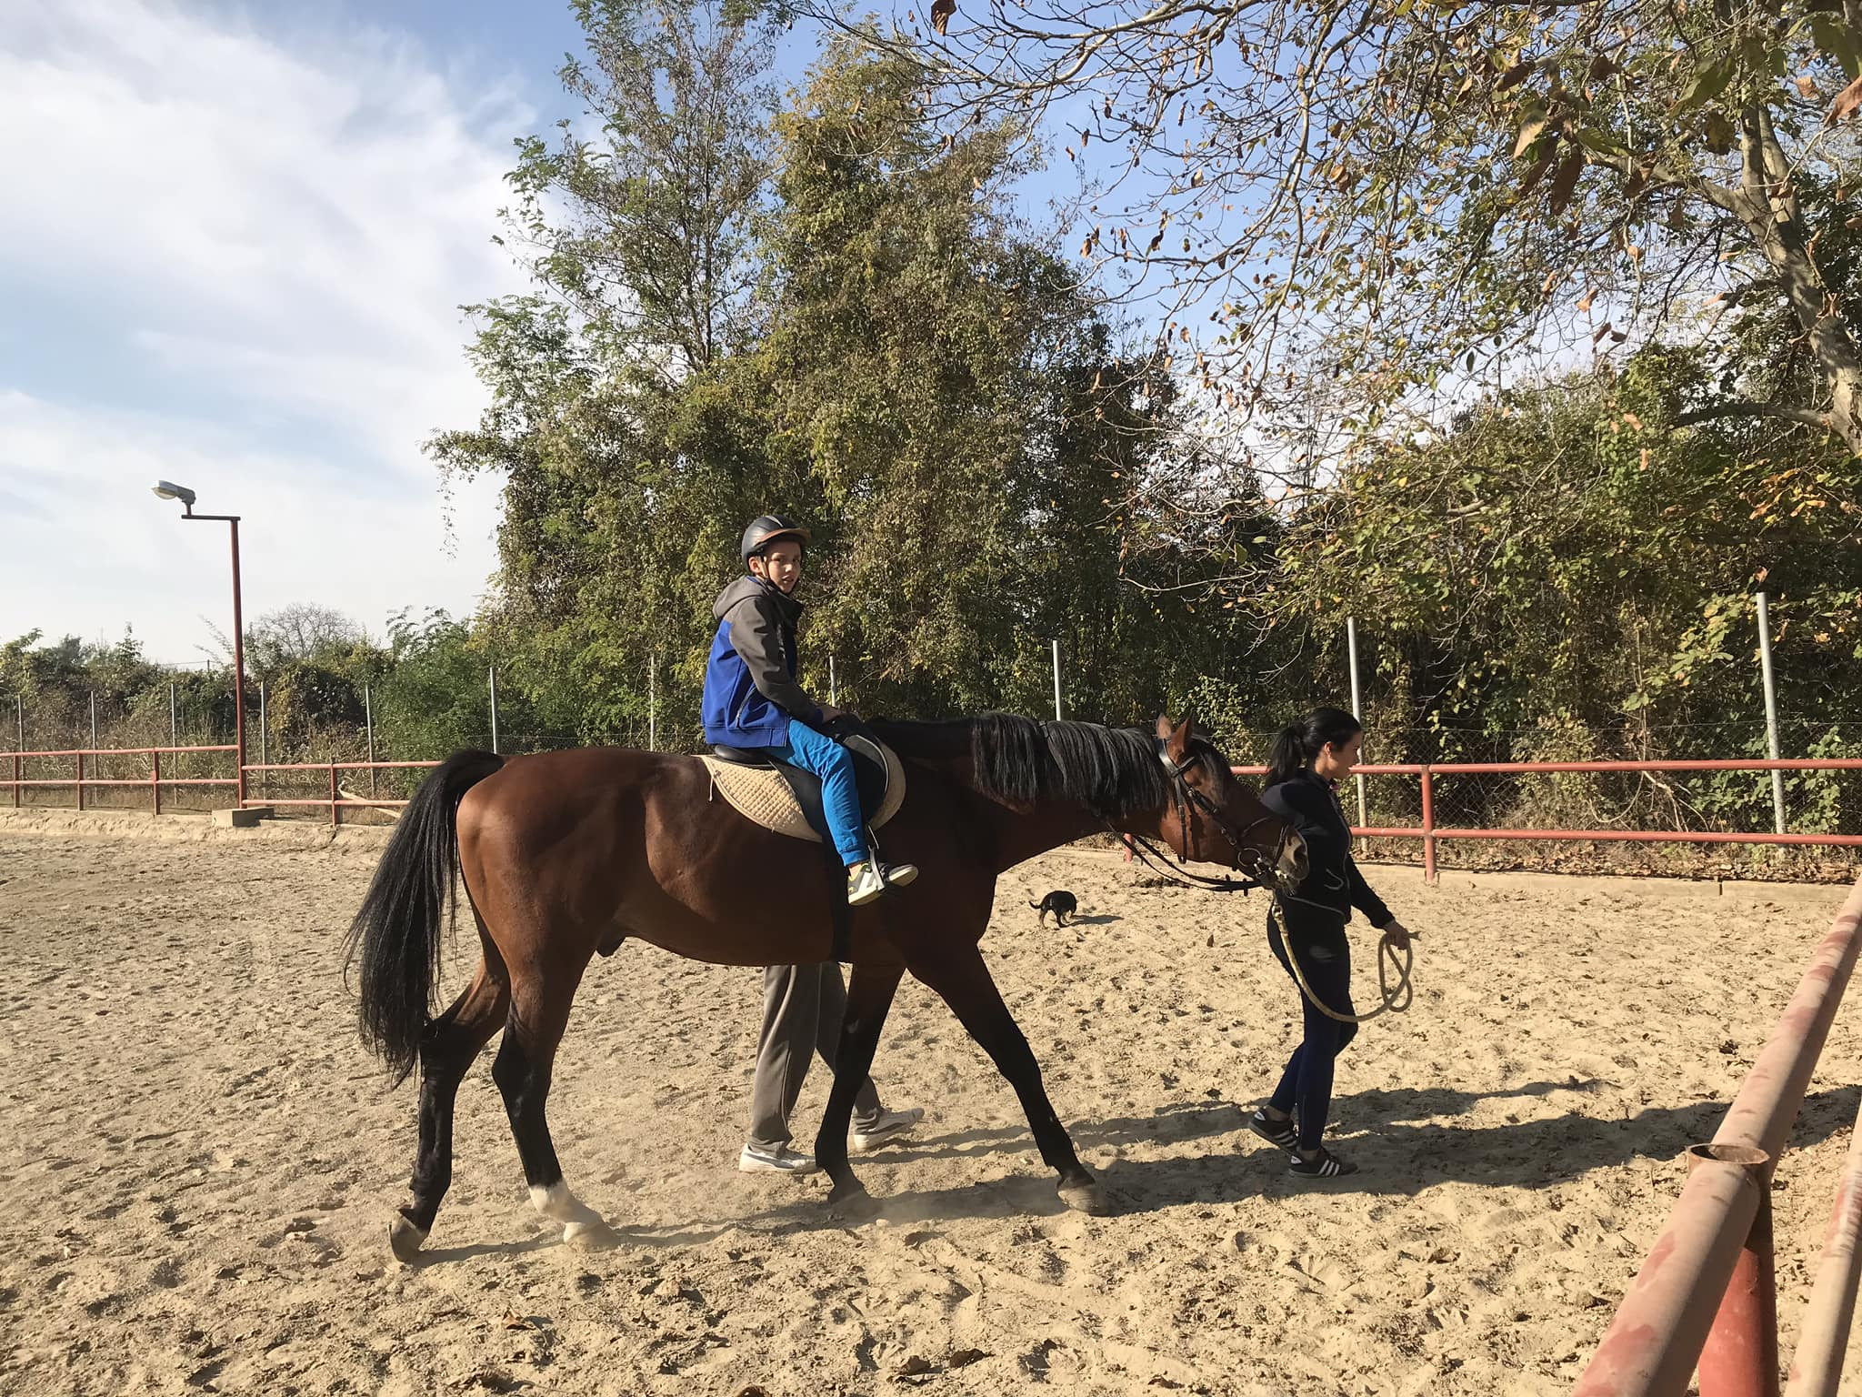
Hypotherapy- riding

