

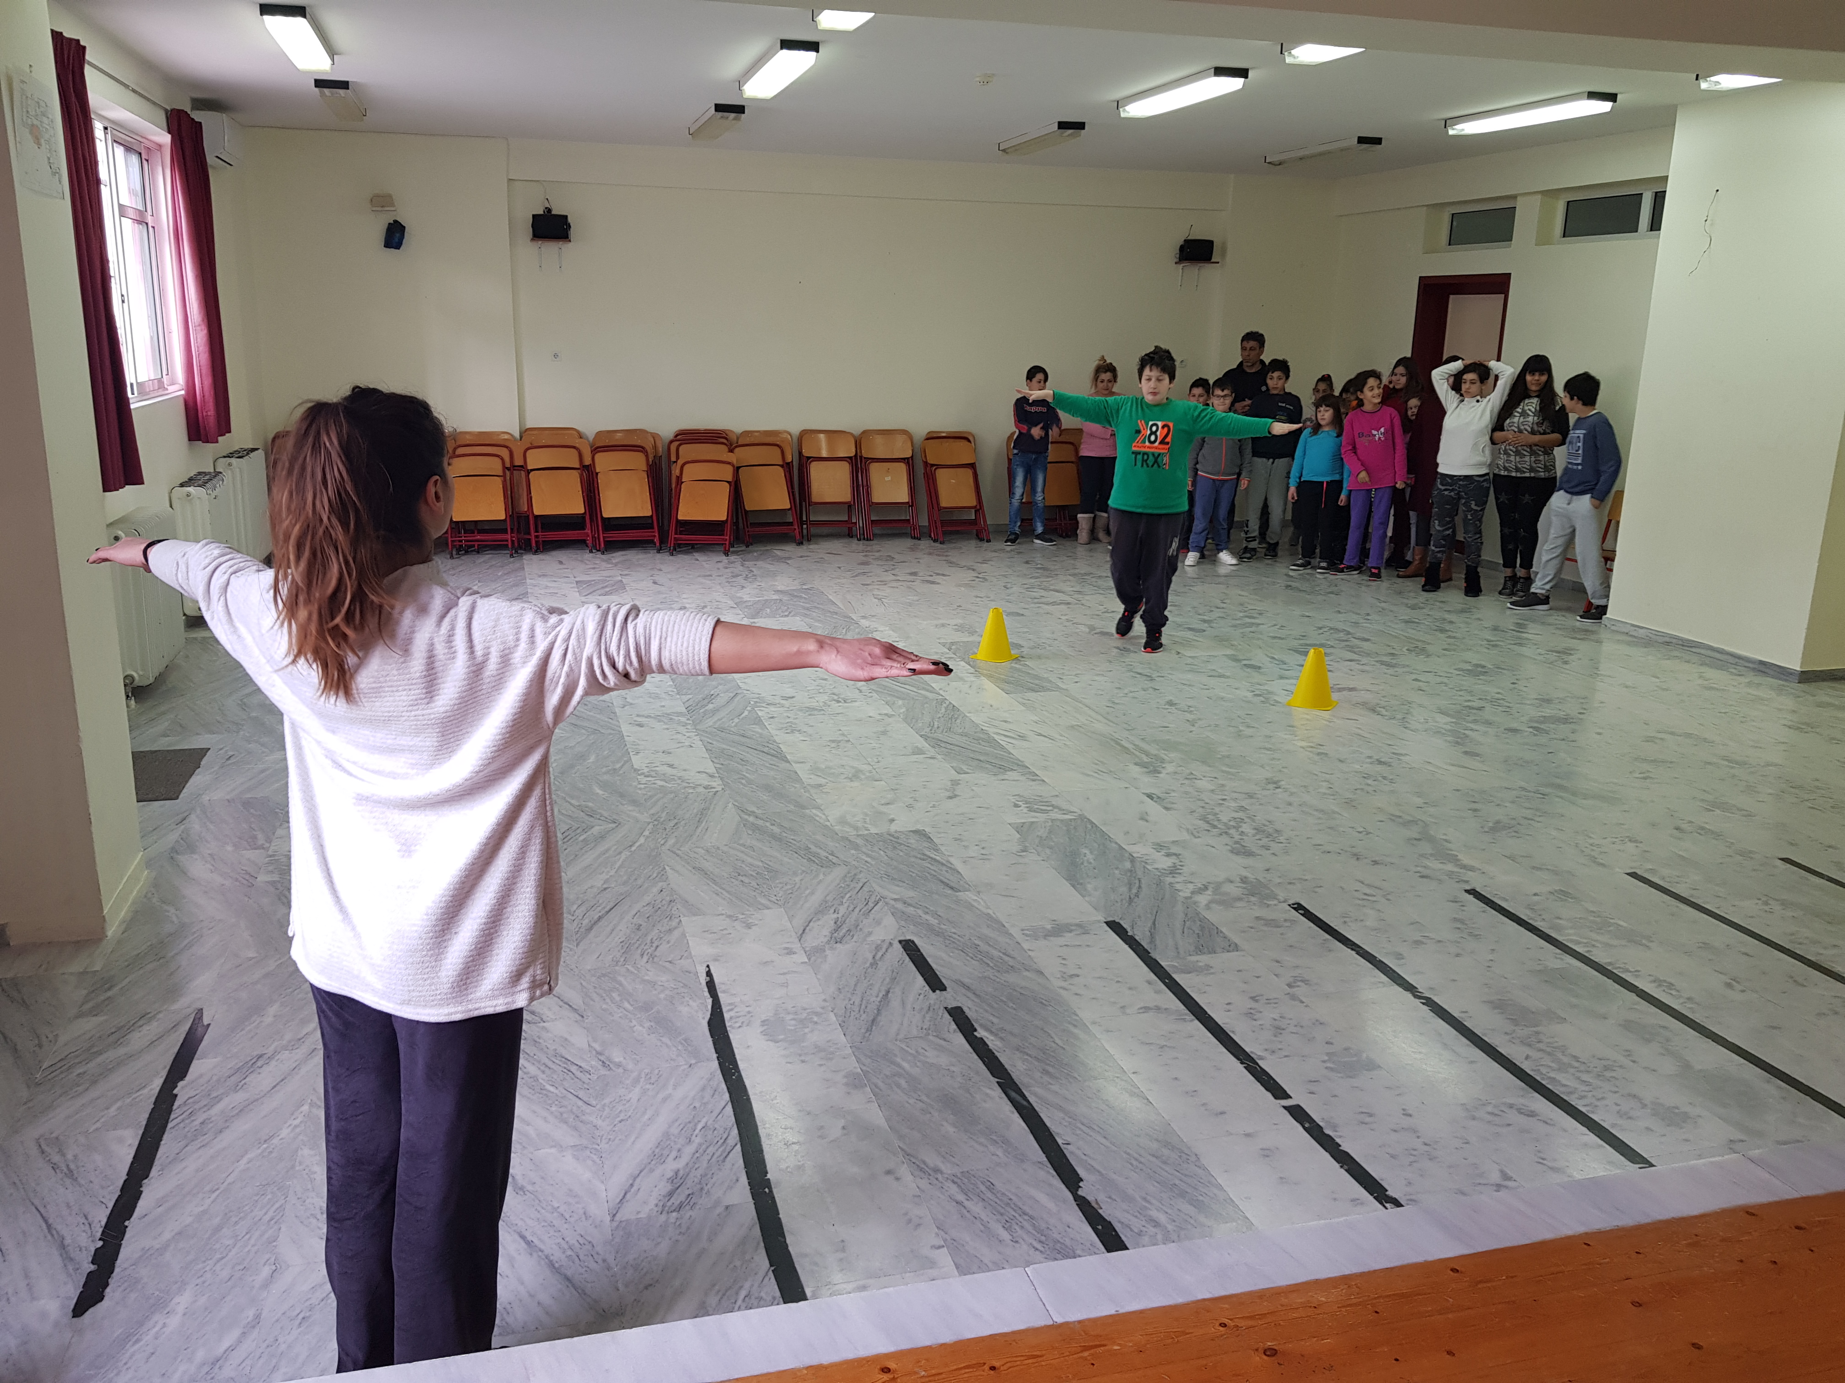
Indoor Activities -Rhythmic Gymnastics at the school

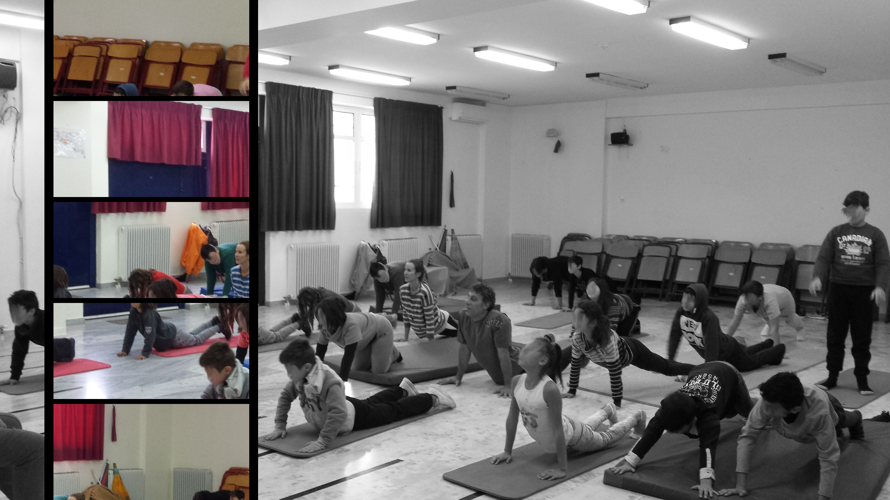
Indoor Activities -Yoga exercises at the school

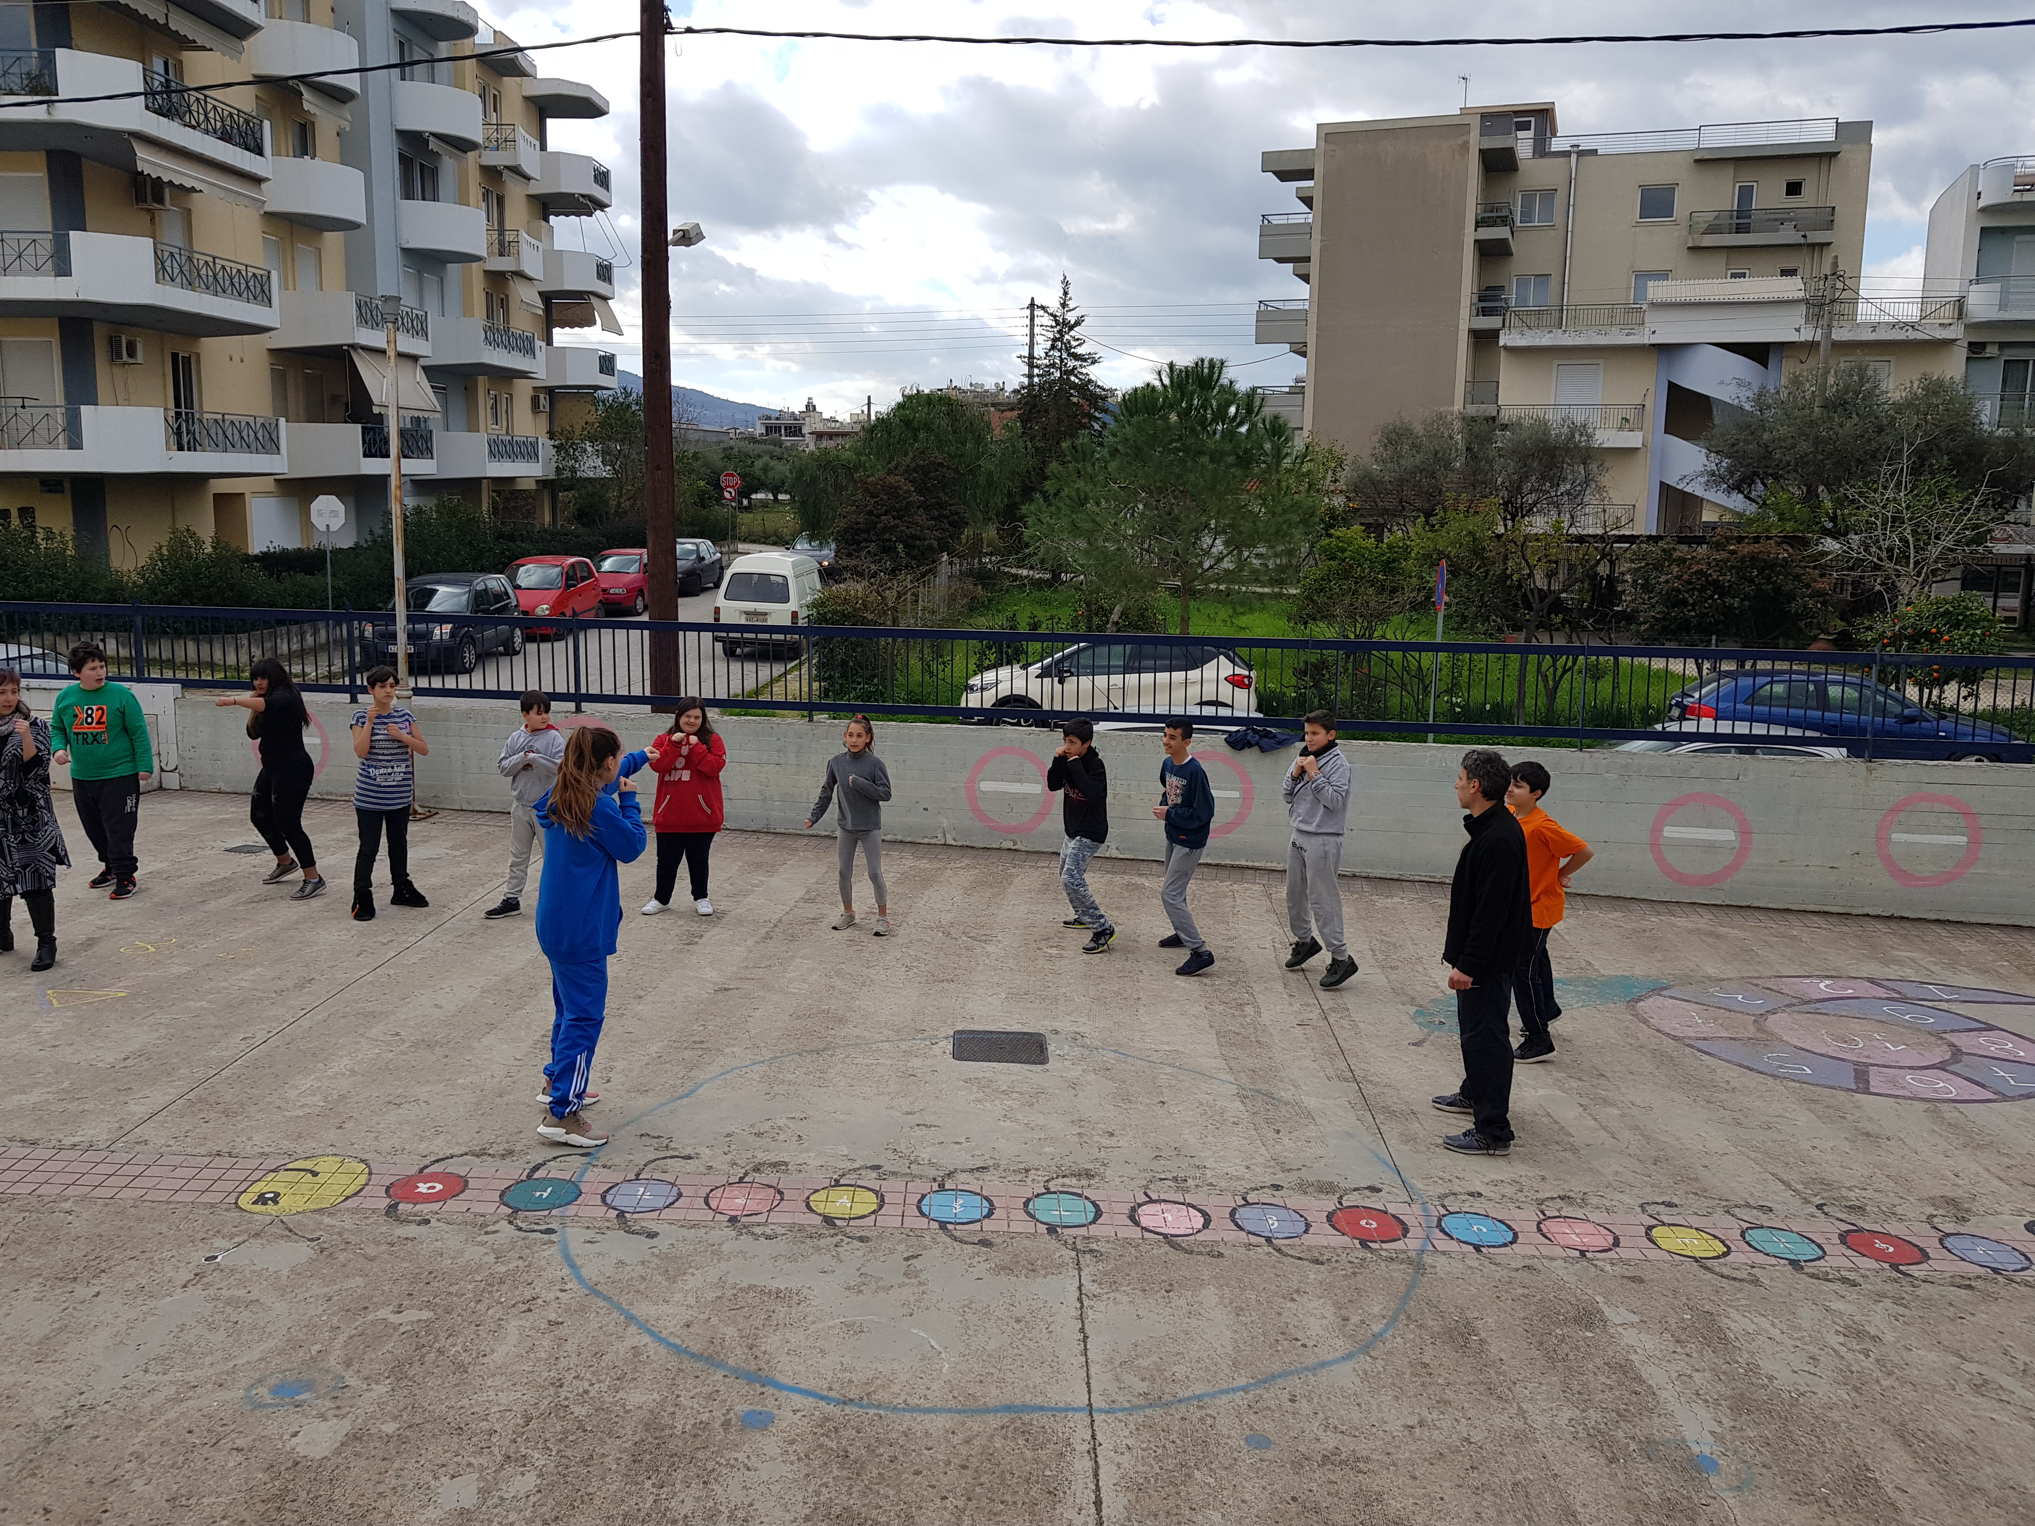
Outdoor Activities -Boxing exercises at the school yard

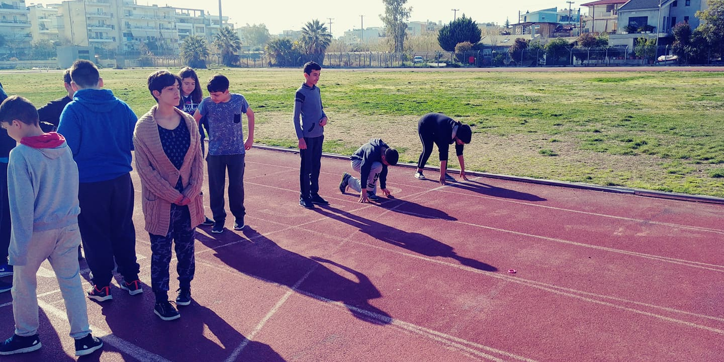
Outdoor Activities -Visit to open track field in SEGAS athletic centrum
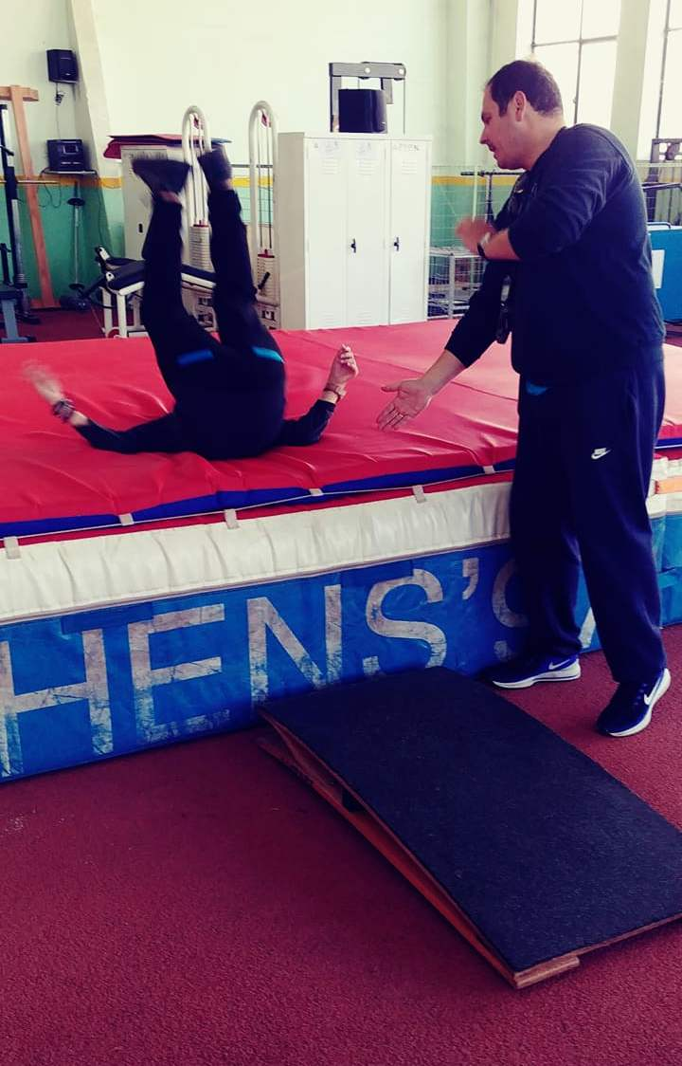
Indoor Activities -Visit to indoor track and field sports in SEGAS athletic centrum

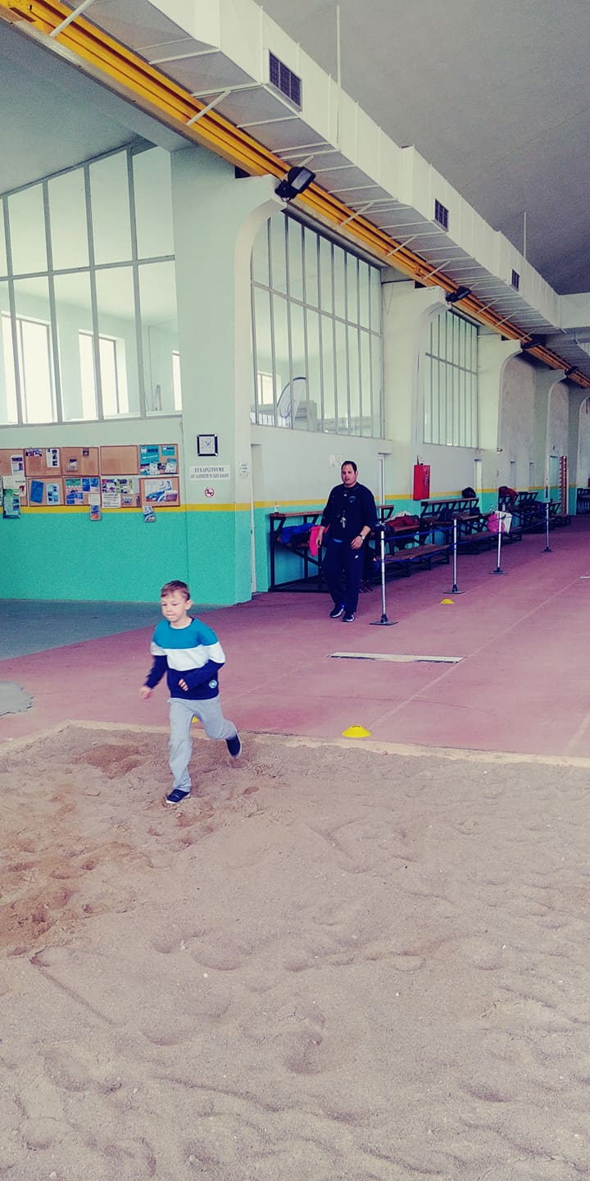
Indoor Activities -Visit to indoor track and field sports in SEGAS athletic centrum

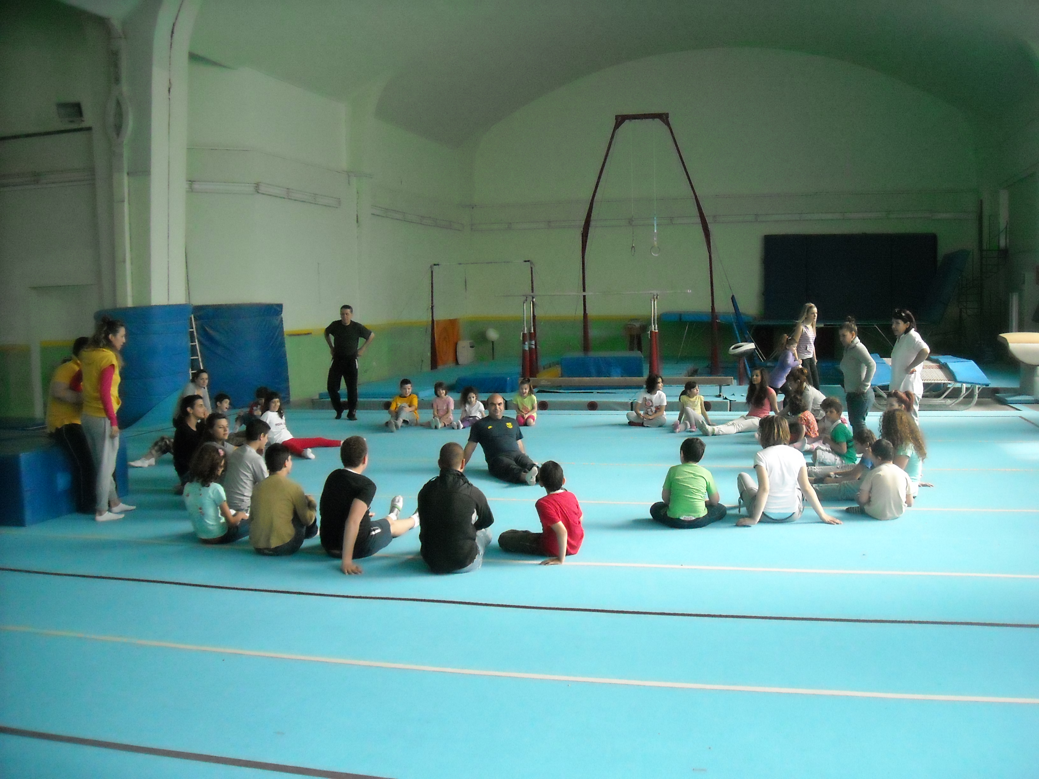

Indoor Activities -Visit to indoor gymnastics in SEGAS athletic Centrum

